* Logistic regression is a statistical method for predicting binary classes
* It computes the probability of an event occurrence.

**Equation is:**

http://res.cloudinary.com/dyd911kmh/image/upload/f_auto,q_auto:best/v1534281880/image1_ga8gze.png

Where, y is dependent variable and x1, x2 ... and Xn are explanatory variables.

**beta_0, beta_1 … beta_n** : are the logistic regression coefficients/ slopes.

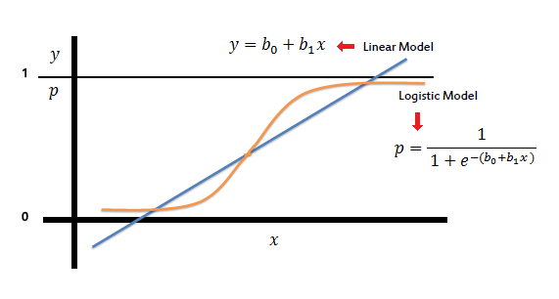

**Sigmoid Function**

* The sigmoid function, also called logistic function, gives an ‘S’ shaped curve that can take any real-valued number and map it into a value between 0 and 1.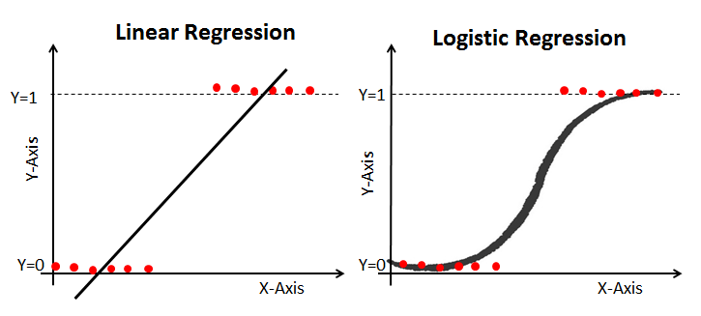

**Apply Sigmoid function on linear regression:**

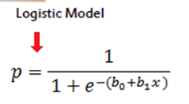

**P : is the probability of an event to occur**

It maps probability ranging between 0 and 1

In order to calculate probability we need **Odds ratio**



**Odds range from 0 and positive infinity**

The **coefficient (*b0, b1..*)** are the amount change with a one unit change in *x*.

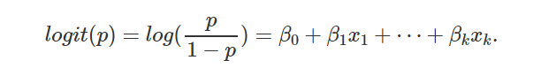

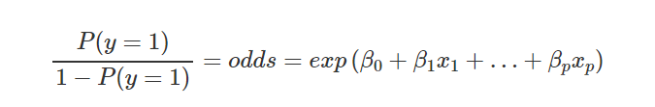

Exponentiation and take the multiplicative inverse of both sides,

Adding 1 both sides

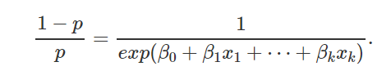

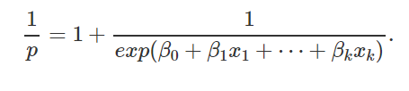

Changing to common denominator

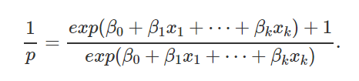

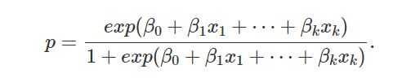

* If the curve goes to positive infinity, y predicted will become 1, and if the curve goes to negative infinity, y predicted will become 0. The sigmoid function shrinks these values.
* If the output of the sigmoid function is more than 0.5, we can classify the outcome as 1 or YES, and if it is less than 0.5, we can classify it as 0 or NO
* Logistic regression becomes a classification technique only when a decision threshold is brought into the picture.